Lead to Quote to Won Opportunity

Lead Creation

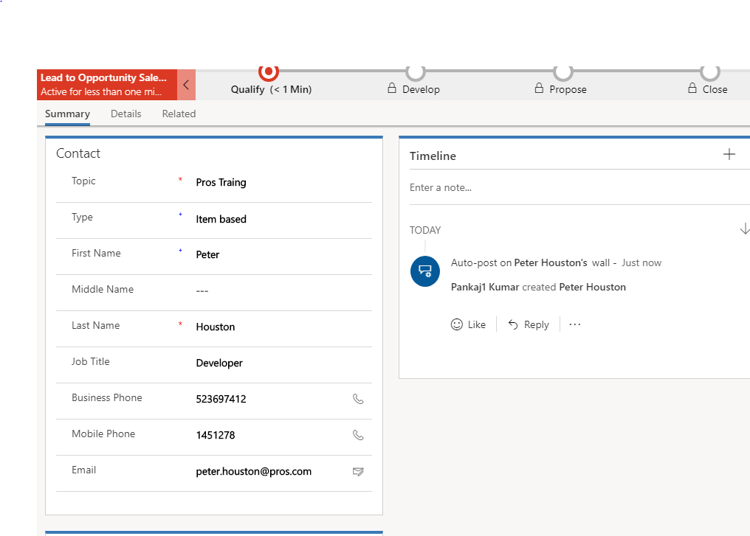

Fill are the required details in the lead page.

Qualify The Lead

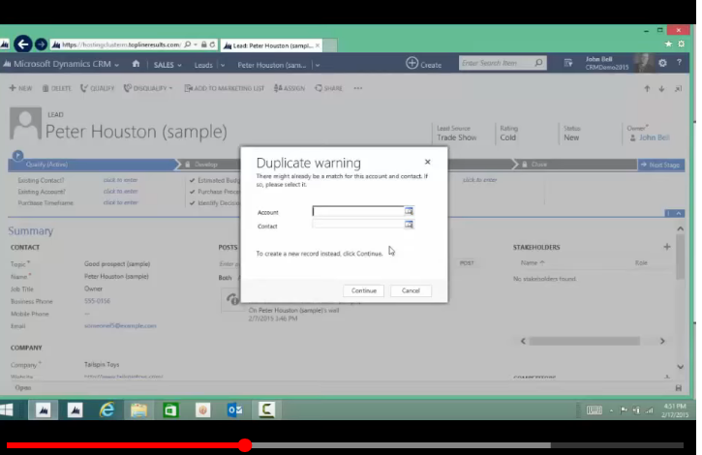

Once the lead is qualified the opportunity is created.

Opportunity

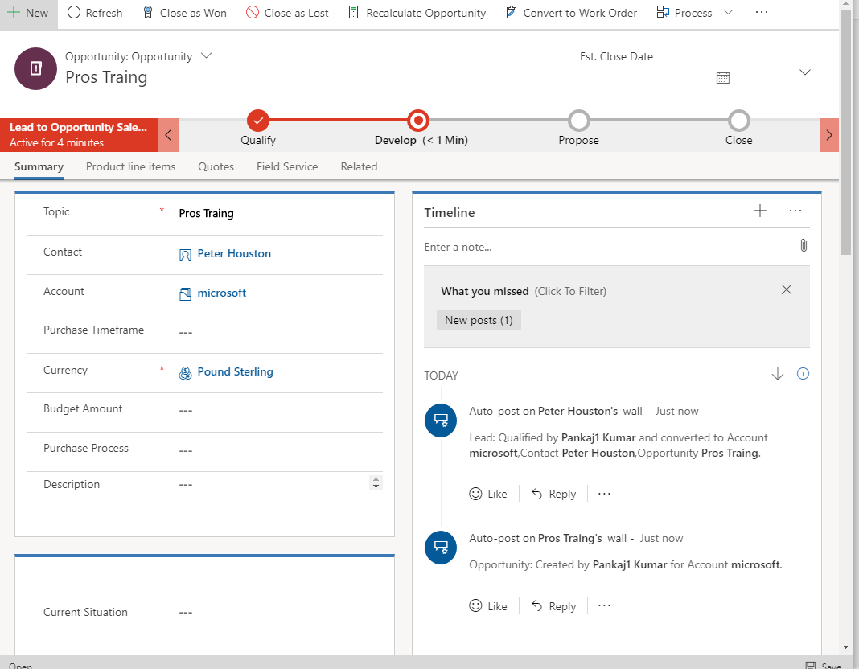

Give the estimated close date, as well as the est revenue and the status keep it as in progress.

Product Line items

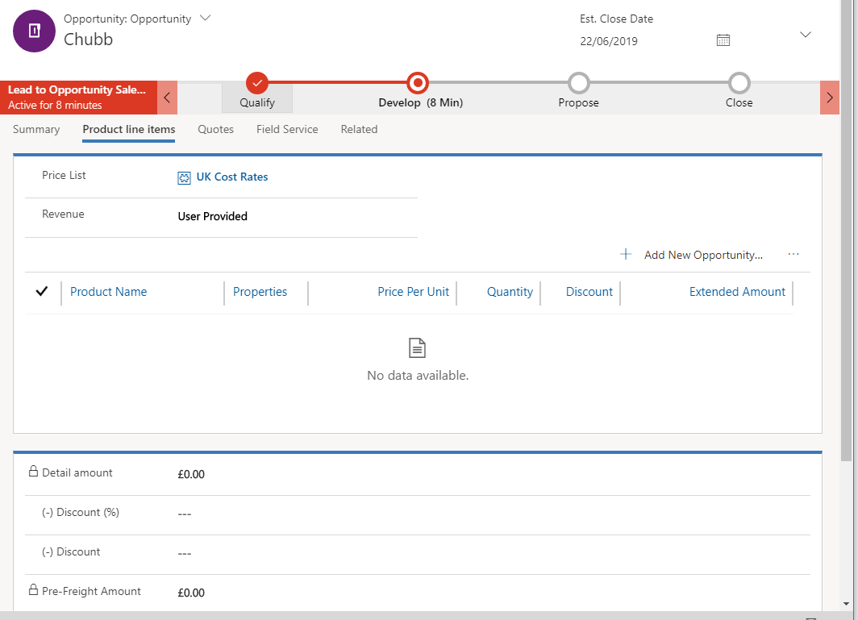

Add products in the product line item.

Quote

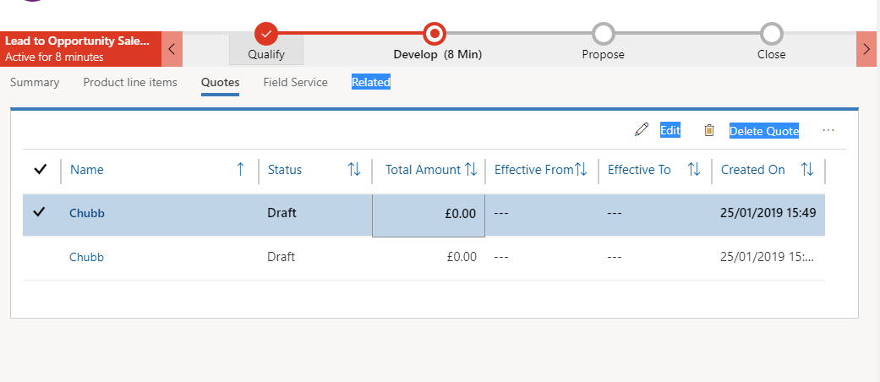

Quote is created with product line items.

Report

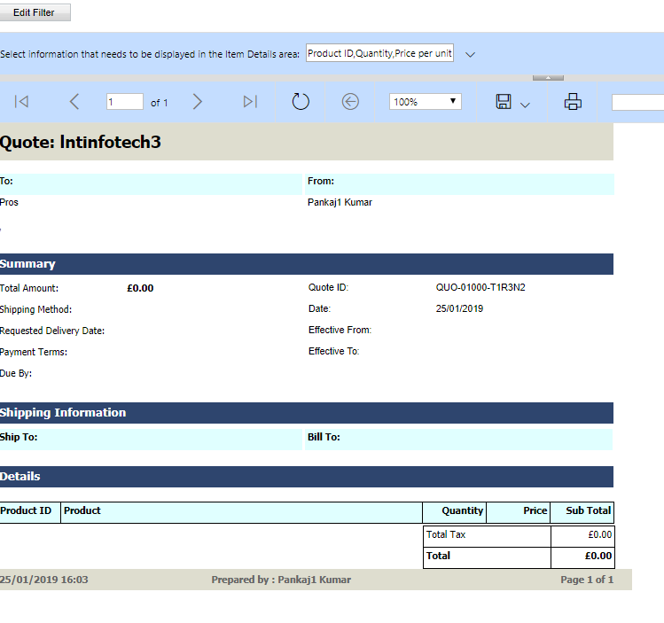Reports are generated once the quote is created which is given to the customer for their refrence.

Activate Quote

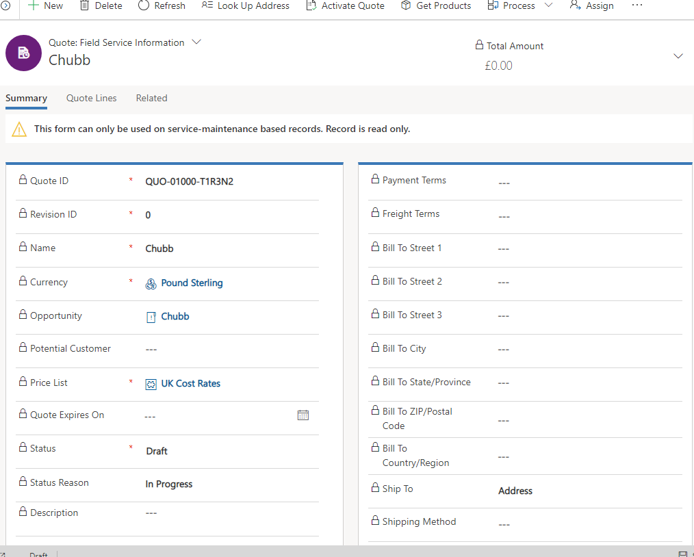

Create Order

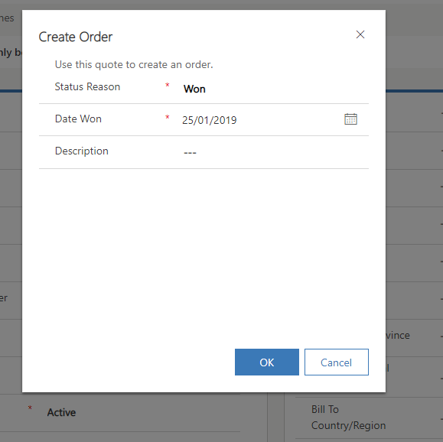

Order Created

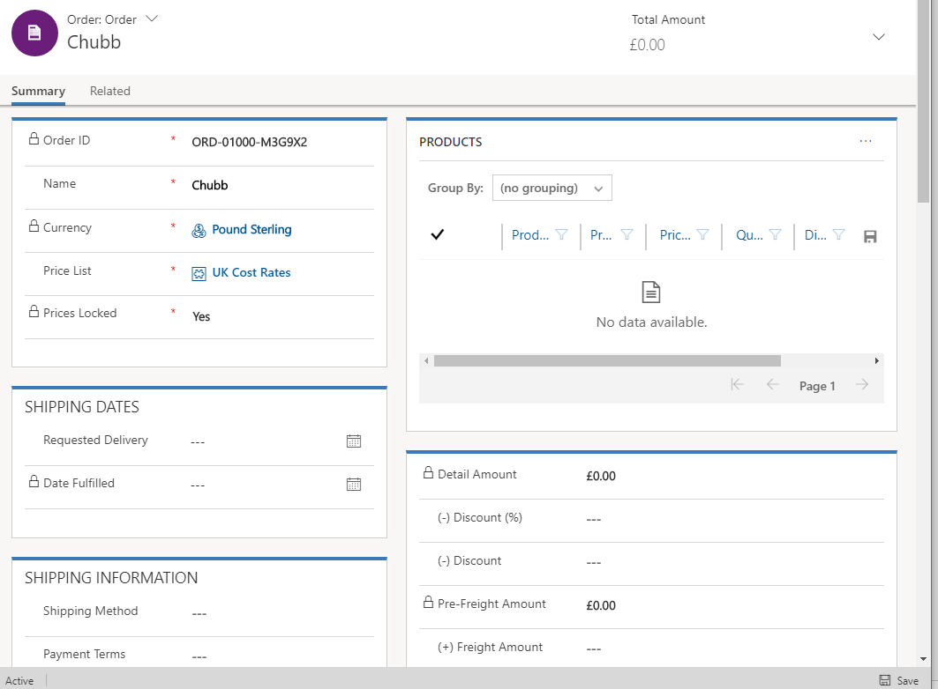

So this the overall workflow from lead to order, We can further create the invoice also.